Retail Intelligence — Executive Summary
Henry Nwankwo — NCPL AI Data Analyst Bootcamp, Cohort 3 — Project 1, Day 4

1. Which category and region gives the highest revenue?
Electronics is the top-performing product category, led by batteries, chargers, and cables/mobile accessories. Dubai is the top-performing city, generating roughly double the revenue of Abu Dhabi and more than triple that of Sharjah — the three cities account for all store revenue in this dataset.

2. How many customers are at risk of leaving?
Using RFM segmentation, 276 customers (5.5% of the base) are classified “At Risk” — historically high spenders who haven't purchased recently. A further 756 customers (15.1%) are already “Lost.” Together, roughly 1 in 5 customers need active re-engagement. By contrast, 522 customers (10.4%) are “Champions” and 1,479 (29.6%) are “Loyal,” representing the base's strongest retention segment.

3. Did promotions help increase sales?
Yes. Average revenue per transaction was 46.4% higher during promotional periods ($120.44) than outside them ($93.19). Total revenue during promotion periods reached $41.1M versus $28.0M in non-promotion periods, despite promotion periods covering fewer transactions overall — indicating promotions meaningfully lift both transaction value and total sales.

Supporting Visuals
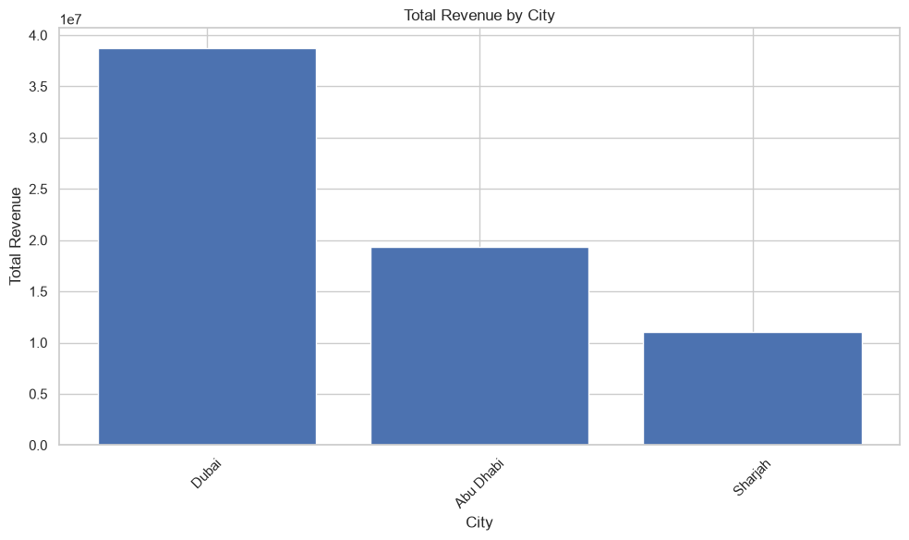  Total Revenue by City | 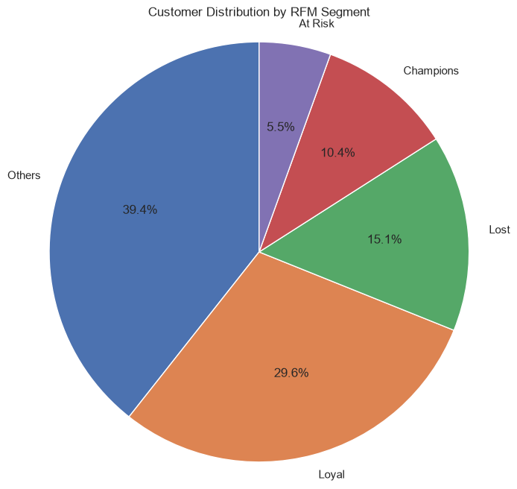  Customer Distribution by RFM Segment

